#Task 01

Training Proposal for Sensor Solutions in Civil Engineering Projects

1. Sensor Selection for Civil Resources

Temperature Sensors

- Civil Resource: Pavements, concrete curing processes, and structural health monitoring.

- Purpose: To measure and monitor temperature variations that can affect material properties and overall structural integrity.

2. Justification for Sensor Selection

Temperature Sensors:

Why: Temperature sensors are important for understanding the thermal behavior of construction materials. Temperature variations can cause expansion, contraction, or other changes in material properties, impacting the overall stability of the structure.

3. Features of Sensor-Enhanced Civil Systems

Temperature Sensor Enhanced Systems:

Feature 1: Continuous temperature monitoring to detect abnormal thermal behaviors.

Feature 2: Predictive analytics for understanding material performance under varying temperature conditions.

Feature 3: Integration with environmental data to correlate temperature changes with external factors like weather conditions.

Conclusion:

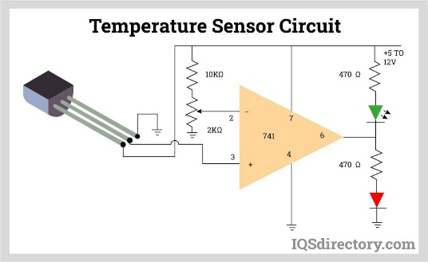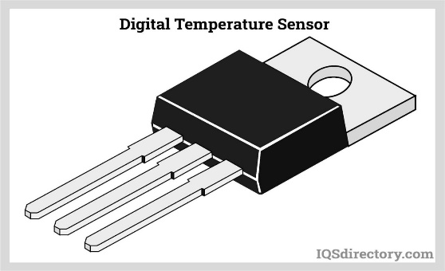The selection of the appropriate sensor technology for civil engineering projects is crucial for ensuring the safety, durability, and efficiency of infrastructure. Temperature sensors each serve unique and essential functions in monitoring and maintaining civil structures. The integration of these sensors into civil systems will provide enhanced monitoring capabilities, data-driven insights, and ultimately, improved project outcomes.

Prepared by: [Bisikishan , Aditya , Vinay ,Sanyam, Shivam], Civil Project Development Engineer